[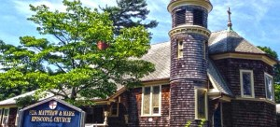](http://bonebuildersri.com/user/matthewandmark/)

**BARRINGTON**

**Saints Matthew and Mark Episcopal**5 Chapel Rd. Barrington, RI

Mondays at 11:00AM |

Wednesdays 9:30AM | Fridays at 9:30AM

[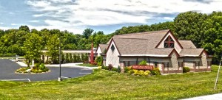](http://bonebuildersri.com/user/aidan/)

**CUMBERLAND**

**St. Aidan Parish**1460 Diamond Hill rd. Cumberland, RI

Tuesday and Thursday at 1:00PM

[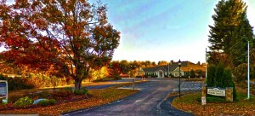](http://bonebuildersri.com/user/gscenter/)

**GLOCESTER**

**Glocester Senior Center**1210 Putnam Pike Chepachet, RI*

Tuesday at 10:30 and Friday at 9:15

[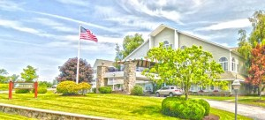](http://bonebuildersri.com/user/thevwl/)

**GREENVILLE**

**The Village at Waterman Lake**715 Putnam Pike Greenville, RI

Tuesdays and Thursdays at 10:00AM

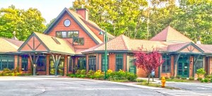

**LINCOLN**

**Lincoln Senior Center* (Starting Feb. 2)**

150 Jenckes Hill Rd, Lincoln, RI

Wednesdays at 1:00PM and Fridays at 9AM

[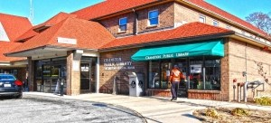](http://bonebuildersri.com/user/cranston/)

**CRANSTON**

**Cranston Senior Center**

1070 Cranston St. Cranston, RI   
Mondays 9AM and Fridays at 1:00PM

[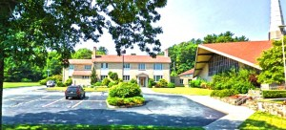](http://bonebuildersri.com/user/stmichaels/)

**GEORGIAVILLE**

**St. Michael's Church**80 Farnum Pike Smithfield, RI

Tuesday and Thursday at 10:30AM

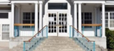

**GREENVILLE**

**Greenville Public Library**

573 Putnam Pike, Greenville, RI

Mondays at 6:00PM

[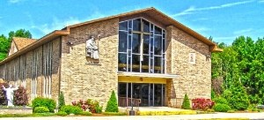](http://bonebuildersri.com/user/robertbellarmine/)

**JOHNSTON**

**St. Robert Bellarmine**1804 Atwood Ave. Johnston, RI

Wednesday and Friday 10:30AM

[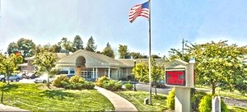](http://bonebuildersri.com/user/salmancini/)

**NORTH PROVIDENCE**

**Salvatore Mancini R.A.C.**2 Atlantic Blvd. North Providence, RI

Monday and Thursday at 10:30AM

[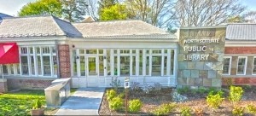](http://bonebuildersri.com/user/nslibrary/)

**NORTH SCITUATE**

**North** **Scituate public Library**  
606 W. Greenville rd. North Scituate, RI

Tue. and Fri. at 1:30PM | Saturdays at 10:30

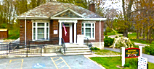

**PASCOAG**

**Pascoag Public Library (Starting February 12)**

57 Church St., Pascoag, RI

Monday and Fridays at 1:30

[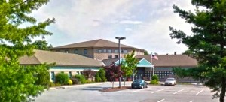](http://bonebuildersri.com/user/pilgrimsenior/)

**WARWICK**

**Pilgrim Senior Center**27 Pilgrim Parkway Warwick, RI

Mondays, Wednesdays and Fridays at 10:45

Wednesdays 4:30PM

[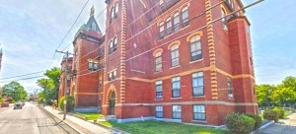](http://bonebuildersri.com/user/chateauclare/)

**WOONSOCKET**

**The Chateau Clare**  
16 Greene St. Woonsocket, RI

Mondays and Wednesdays 10AM

[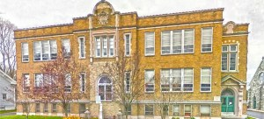](http://bonebuildersri.com/user/stpaul/)

**NORTH SMITHFIELD**

**St. Paul's Parish Community Center**81 St. Paul st. North Smithfield, RI

Tuesday and Thursday at 8:45AM

[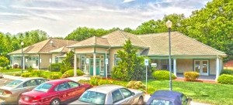](http://bonebuildersri.com/user/smithfieldseniorcenter/)

**SMITHFIELD**

**Smithfield Senior Center**1 Wm. J. Hawkins Jr. Trl Smithfield, RI

Mondays and Thursdays at 10AM

[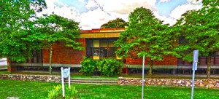](http://bonebuildersri.com/user/wwlibrary/)  
**West Warwick Public Library**1043 Main St. West Warwick, RI

**WEST WARWICK**

Mondays and Wednesdays at 2PM